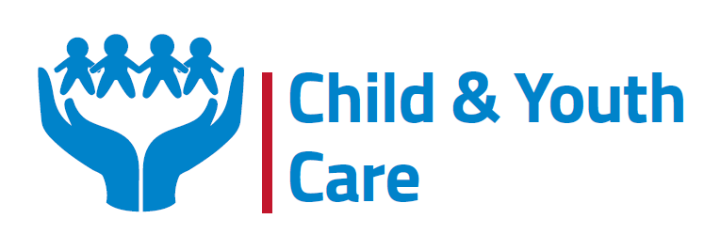
CYC 2023 IN PICTURES
WHOLE GENOME SEQUENCING
Our main thrust for the year was on conducting WGS on patients to help them to get a diagnosis early. Living with a rare or undiagnosed disease can have negative impact on the emotional wellbeing of patients and families. We managed to test 28 clients this year. We would like to thank all the partners for working hard and efficiently to ensure that all the processes worked smoothly. This has been a major milestone in the rare disease community in Zimbabwe as it has helped in the diagnosis journey and pave way for treatment options .WGS has generated interest in the medical field as most health care professionals are now more eager to research and partner with us in raising awareness and the diagnostic journey of rare disease patients.
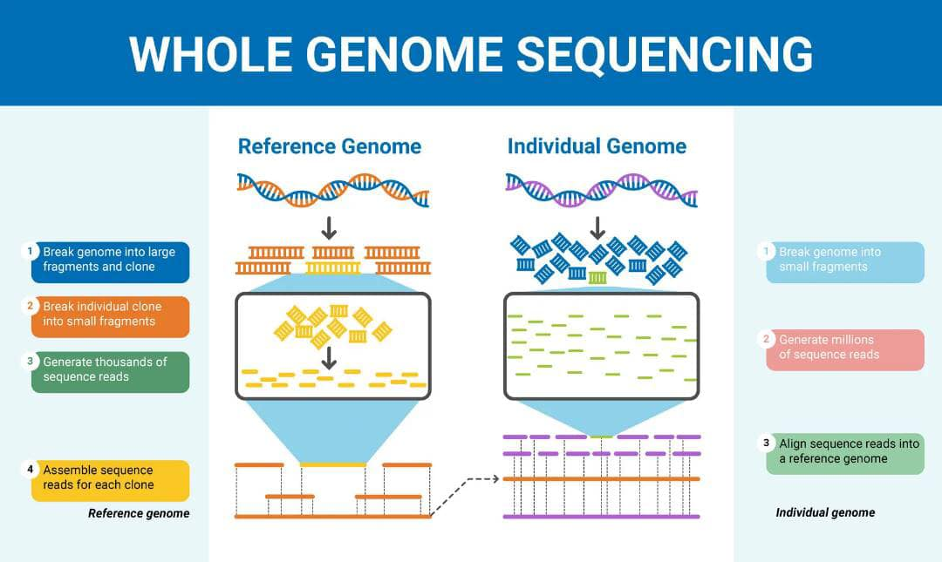

Mental Health
The importance of a sound mind and positive thinking is fundamental in the life of a patient as it determines the response to treatment and social wellbeing of a person. It is one of the strong pillars that we focused on to help PLWRD to cope with the challenges that they face on their journey. We have partnered with Dr Mwazha a mental health specialist to help our clients by providing counselling services to families. We managed to organise counselling sessions for all the families that received their WGS results for them to understand what it means and address any fears or concerns that they had. The counselling sessions were indeed fruitful as the families got the time to speak out and express how they were feeling in the sessions done. It is a continuous process, and we are hoping to arrange many more sessions for them.

Projects
We managed to do a chicken project in partnership with Nedbank. Six families benefited from the project, and it was very successful as they managed to sell the chickens and book for other batches. We are hoping to add more families so that they will be able to improve their livelihood and be empowered in the communities they live in.
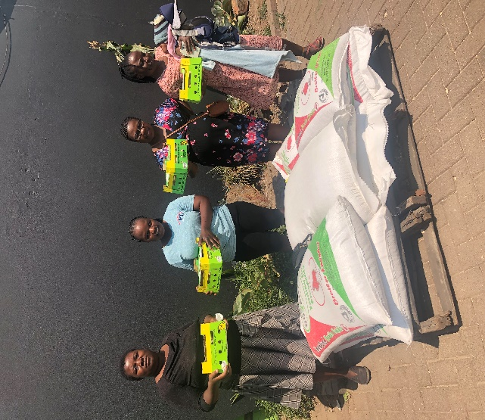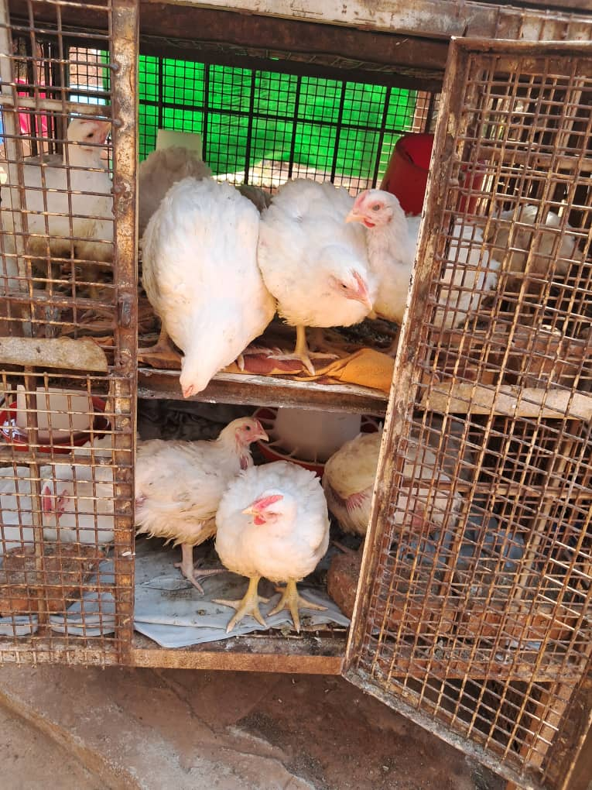
Mukuru For good Project
Donated stationery and books to the rare disease community.

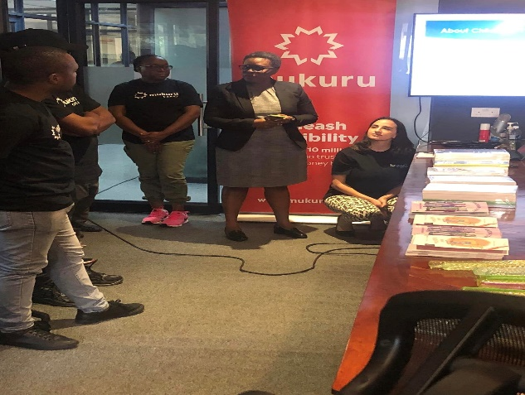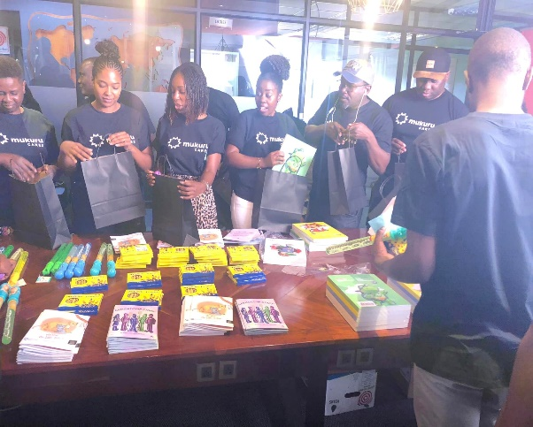

Meetings
CYC was able to collaborate with local and international rare disease partners throughout the year through participating in workshops, webinars, and meetings to strengthen our ties and push for the recognition of rare disease in the community.
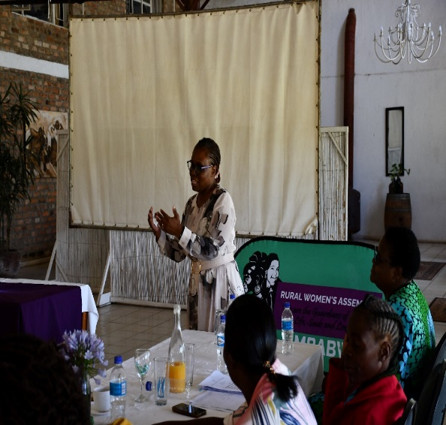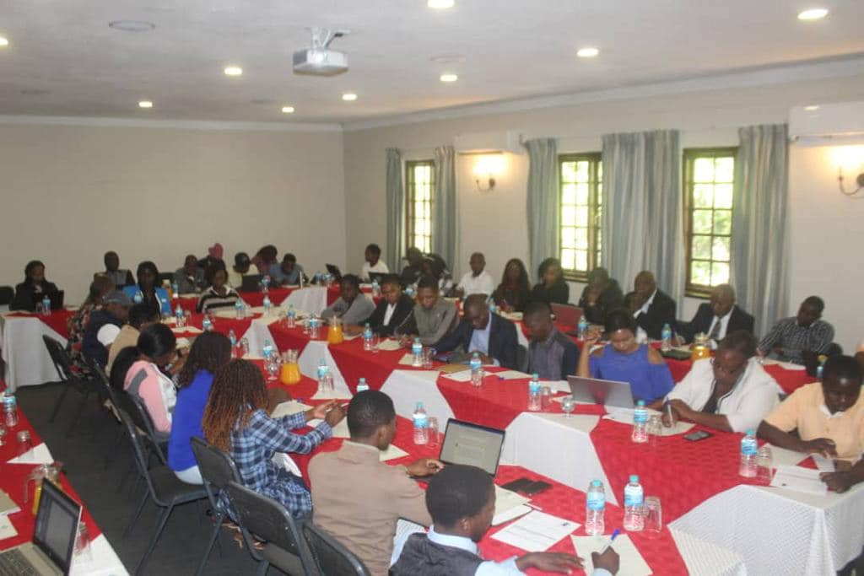
Board Meetings
Managed to have board meeting once every quarter with board members to report and have a strategic road map for our organisation. We are grateful for the support that we get from the board members.

Conferences
On the 15th of March 2023, our director, Mrs Nyakambangwe attended the International Rare Diseases Research Consortium assembly in Berlin, Germany. The aim of the conference was to bring together scientific leaders and experts to present cutting edge research, exchange ideas and discuss rare diseases research policies.
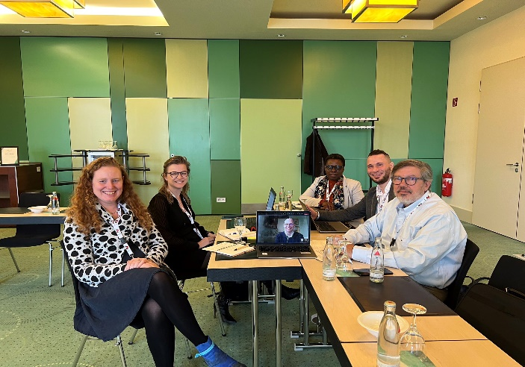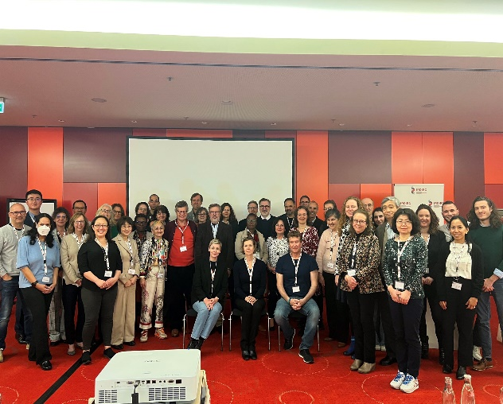

Our director attended the Global Genes conference in USA and joined a panel of experts and presented on how to ensure patient participation in clinical trials and research.

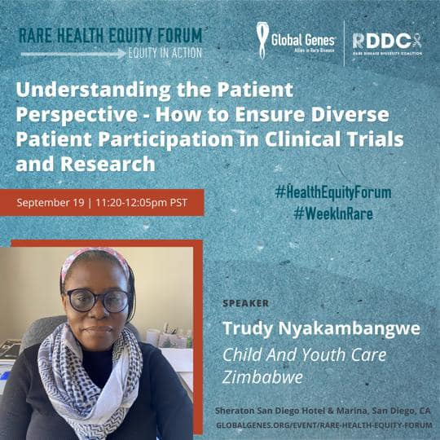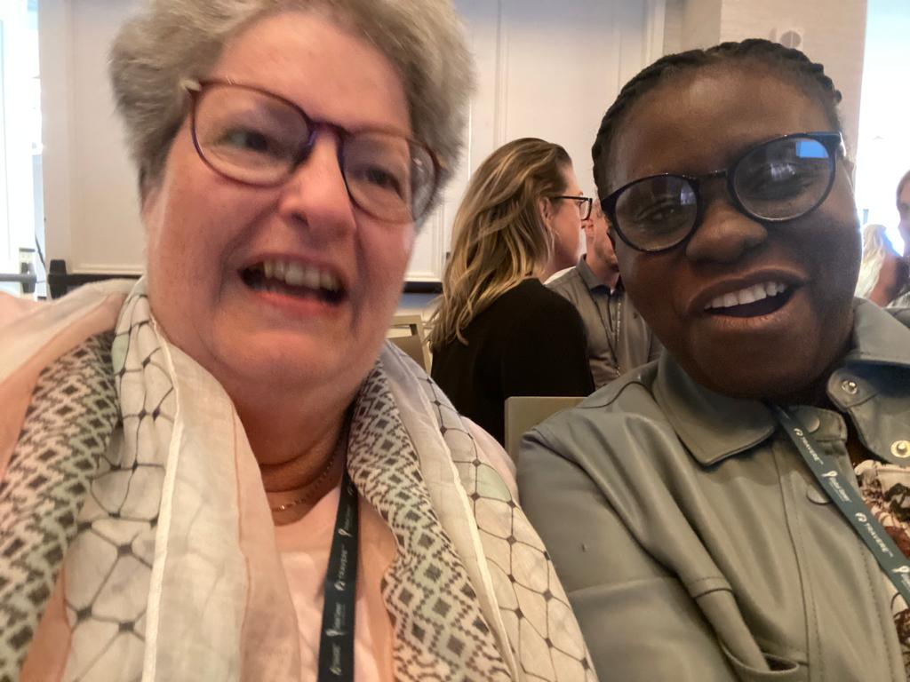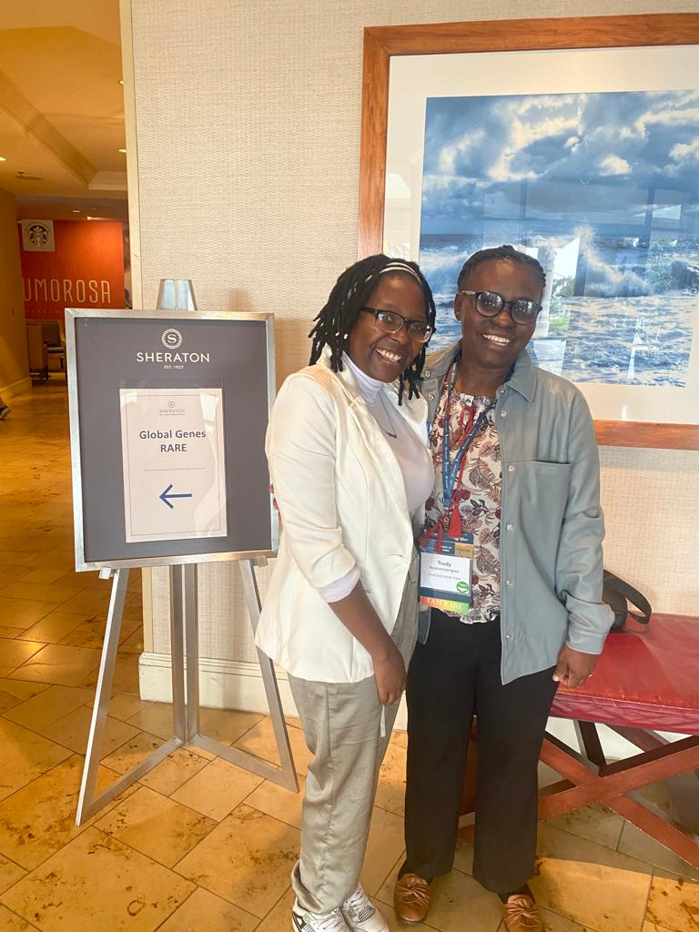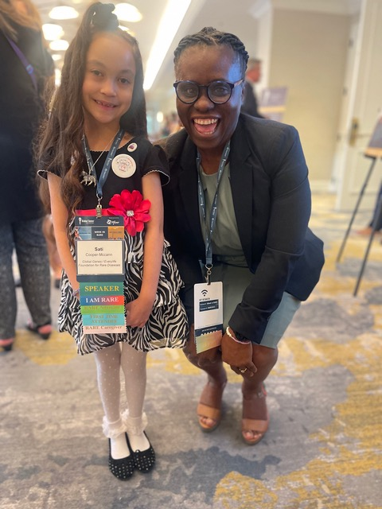

Rare Disease Day
Participated on the Rare disease day in February and we had an Art Exhibition at The Heritage school were children participated by drawing pictures which were then displayed on the day. There were prizes for those who had the best pictures. We also invited families of our clients who have rare disease to commemorate rare disease day.

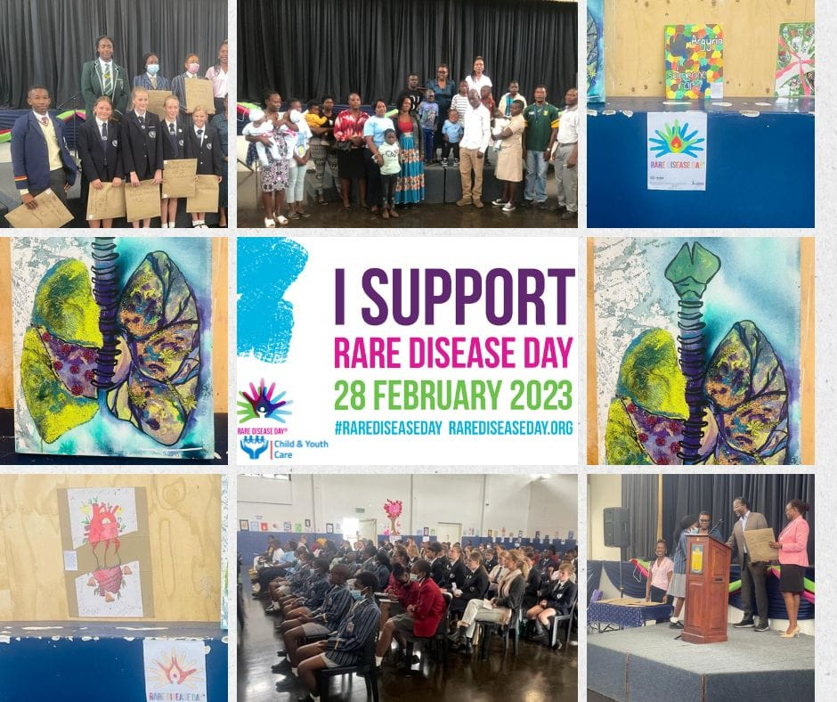

World Haemophilia Day
Child and Youth Care and partners, Zimbabwe Haemophilia Association participated in a campaign awareness for the commemoration of haemophilia day. Key highlight from the campaign awareness included the dissemination of information about haemophilia rare condition to hard to reach areas.
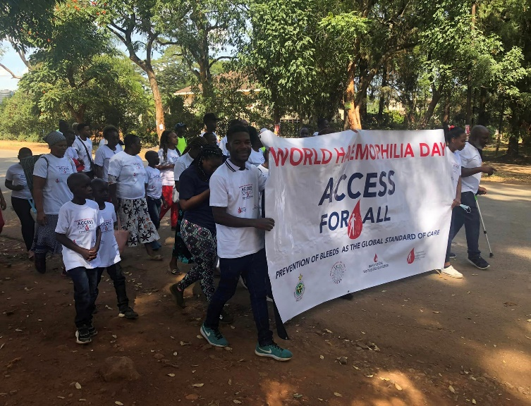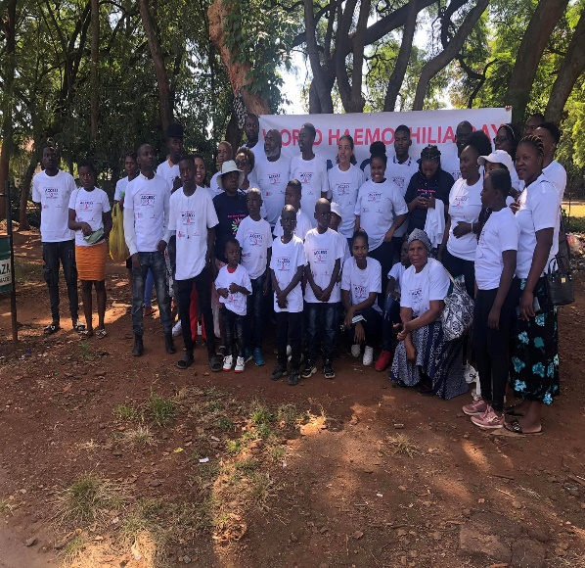

End of year Membership Event
Organised a membership meeting in December and invited all our partners and clients to come together. There was a mental health session and patient testimonials on their journey where they discussed on the challenges that they faced and giving advice to other parents. We also invited Dr Bara from the City of Harare health department to join us, and he reiterated the importance of community engagement and the use of local clinics to support rare diseases.
